Ben Eater

The YouTuber who built an 8-bit computer from scratch

By: Megan Tung
Ever want to learn to build an 8-bit computer from scratch? Now you can with Ben Eater's 44-part YouTube video series and his 8-bit computer kit bundle. On his YouTube channel, Ben Eater creates educational videos about electronics, computer architecture, networking, and various other technical subjects.
After traditional schooling didn’t work out for him, Ben left college and started interning at a company. During his internship he was able to gain the knowledge he was seeking. Now he uses his YouTube channel to spread the knowledge he learned during his time as an engineer.
As a child he was always looking for ways to explore his interests, so he believes his channel would have been something that he would have enjoyed back then. Ben has previously worked on networking hardware at his own startup and worked in sales and engineering roles at larger tech companies. He worked at Khan Academy where he built over one hundred interactive math exercise modules and managed platform engineering. Ben now pursues a full-time career creating educational instructional videos.
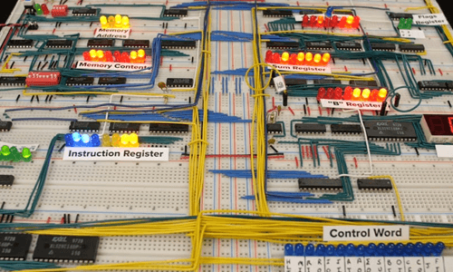

8-Bit Computer
Ben Eater’s biggest project is building an 8-bit computer from scratch. Through a 44-part video series, he walks you through how to build your own 8-bit computer. The bundle comes with four kits: Clock Module, Registers and ALU (Arithmetic and Logic Unit), RAM and Program Counter, and Output and Control Logic. Building your own 8-bit computer will help you to understand the computer basics and how a CPU works.
You will be able to program the 8-bit computer with a set of instructions that it will follow and execute. The registers temporarily store a value during the operation of the computer. The program counter provides the computer with the current address of the instruction to be executed. For more information about the computer and the parts inside, check out the video series.
Some of his other videos include: Comparing C to machine language, Building a Video Card, error detection videos, networking tutorials, and digital electronics tutorials.

Megan Tung is an intern at Jameco Electronics. Megan is a rising junior at the University of California, Santa Barbara. She is interested in photography, music, business, and engineering.

